**Prototype OF the Project**

* **For Encryption**

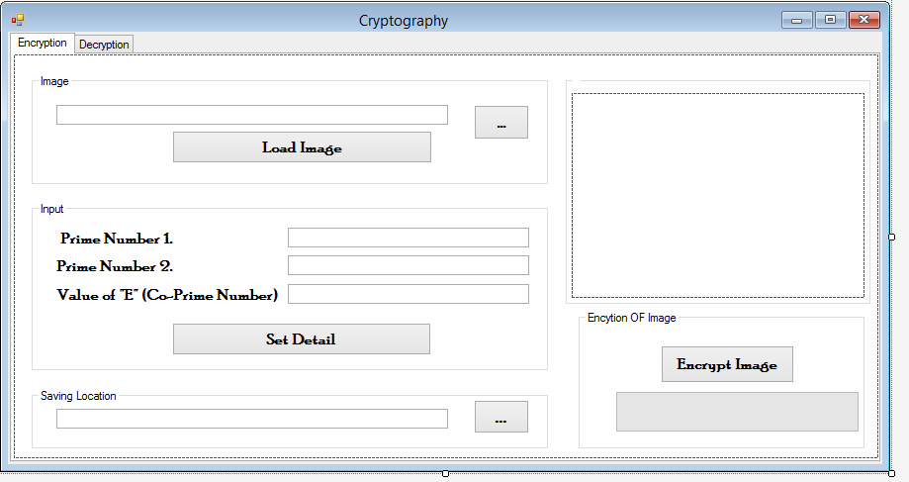

* **For Decryption**

